1.HTML

What is HTML?
Html stands for Hyper Text Markup Language , it is a markup language not a programming language. A markup language is a computer language that uses tags to define elements within a document. It is human-readable, meaning markup files contain standard words, rather than typical programming syntax. While several markup languages exist, the two most popular are HTML and XML
HTML Documents are described by HTML Tags like <h1> (headings), <p> (paragraph),<a>( links).A tags must have opening and closing tag like <h1>(opening Tag) </h1>(closing Tag) and some has only opening tag i.e it is self-closing tag. Browser can read HTML Tag and execute it.
Syntax and basic Structure of html:
Both Head and body tag are optional i.e. can use any one of them gives output with out error
<!--Gives what type of file like html( for broswer telling it is HTML 5,not html element) -->
<!DOCTYPE html>
<!--Always Start with html tag and under we write content -->
<html>
<!--has head and body -->
<head>
<!--It Include tilte of website and css style and some infromantion for browser like script -->
</head>
<body>
<!--It is all the visible element for of web page , it contains all web page content like text,link,images etc-->
</body>
</html>

The Content between <!-- is a comment (in green color ) -->
Tags And Element Attributes :
We can many tags which describe it nature, in above we have seen <title> tag as it gives title of website. We can write tags within in tag ,but recent tag should close first like in above title closed first as its recent and then head tag. Here are some tags and all are using in body

Header Tag : There are six header tags
<h1>
<!-- Heading Tag, increasing number like h2,h3 size decrases -->
Heading 1
</h1>
<h2>
<!-- Heading Tag, increasing number like h2,h3 size decrases -->
Heading 2
</h2>

Output :
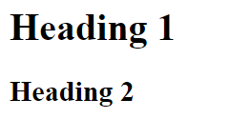

Paragraph Tag: strong for bold, em to italic , br to break a line with in paragraph
<p>
This is paragaph
<strong>This is Strong like bold</strong>
<br><!-- TO break a line move to next line-->
<em>this emphasize line like italic</em>
</p>

Output : here you can see a em start in new line
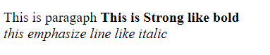
Img Tag: image tag,Element Attributes are which provides additional information of tag or element like src and title

<!--For image, in src we have give source or location of image and alt we give alternative if image is not present tilte is when keep mouse on it display what ever given in title -->
<img src="D:\Images\7.jpg" alt="tobi" title="tobi">
Output :

Link Tag:
<!--Links-->
<!-- href is same as src,it give location of link on click it take us there
target att it shows wher to open link _blank open in new tab -->
<a href="https://www.youtube.com" title="www.youtube.com" target="_blank">
Youtube <!--display name of link on browser-->
</a>
<br>
<!-- not onlylink we give any image docs both outside or current-->
<a href="D:\Images\7.jpg" title="www.youtube.com" target="_blank">
image <!--display name of link on browser-->
</a>

Output:
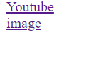
Div Tag: It is also a divide , it helps keep divide page in section and style own section in each way
Header Tag: It is just like div , use for keeping main heading , menu buttons, etc, we use because search engine see as header not any div.
Nav Tag: <nav> tag is used to declaring the navigational section in HTML documents. These links can be placed inside a nav tag. In other words, the nav element represents the section of a page whose purpose is to provide navigational links, either in the current document or to another document.

2.CSS

What is css?
Css stands for Cascading Style Sheet , it defines how HTML looks, HTML is content and CSS is style There are 3 ways of writing CSS:
- Css code inside HTML Tag called as in-line style , it is written in opening tag (in html file)
Eg: <p style=”color:red”>Text comes in Red color</p>
- Css code inside an HTML document ( html file)
Eg: <head>
<style>
P{ color:red}
</style>
</head>
- Css code in external file(separate file extension as.css)
Eg: P{ color:red}
Can be use any thing, try use 3 method for cleaner code,1) overrides if same style in other two, child element inheritance they parent element unless we over rides it

Using External Style sheet in css
To use external css file in html we need to add <link> tag unt html it is self closing tag and rel is a link relation is a descriptive attribute attached to a hyperlink in order to define the type of the link, or the relationship between the source and destination resources, type attribute defined type of file, the following is a example.
<!--for adding extrenal files like css and javascript -->

<link rel="stylesheet" type="text/css" href="style.css">

Css has some set of rules and each consist of selector and declaration block. Le t start with selector
Eg: taking as h1 selector
/* changes all h1 tag in html*/
h1{
color: green;
}

Output: Both h1 tag changes color to green
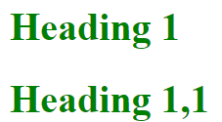

Common declaration if two selector have common given like this avoid repeating of code.
Eg:
/* changes all h1,h2 tag in html, combining all commom features */
h1,h2{
color: green;
font-family: Arial, Helvetica, sans-serif;
}
/* given not common features*/
h1{
font-size: 20px;
}
/* given not common features*/
h2{
font-size: 10px;
}

Classes and ids: classes can be use for a group of tag ,but id for a single tag , even for a single class try to use class only , it is good practice
Class:
/* this is class stat with .*/
.main-text{
font-weight:bold ;
}
Index we have given it more than one tag

<p class="main-text">
kjkjcbkjxkjk
</p>
<p class="main-text">
This is paragaph
<strong>This is Strong like bold</strong>
<br><!-- TO break a line move to next line-->
<em>this emphasize line like italic</em>
</p>

We can give a specific for in specific selector in side class, in bleow only paragraph class img is effect, not all images
.paragraph img{
width: 90px;
height: 90px;

border-radius: 50%;
}

Id: it give for only one tag
/*this id satrt with #*/
#name{
text-align: right;
}

In html
<p id="name">
kjkjcbkjxkjk
</p>

CSS Box model:
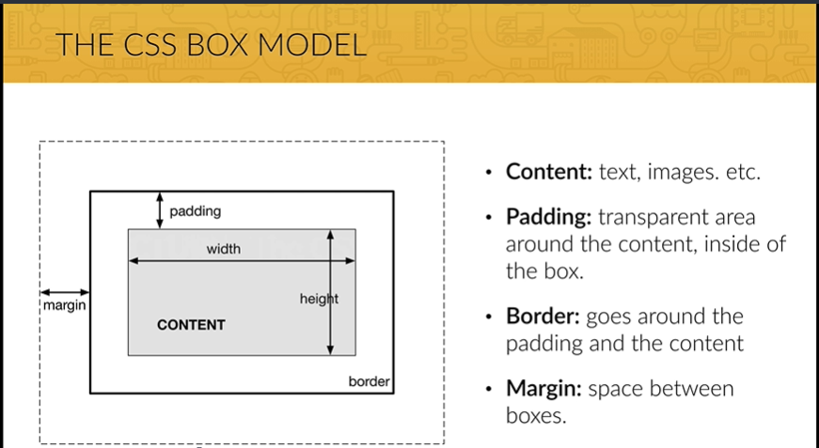

The height and width for content not the box itself , we have go for box-sizing
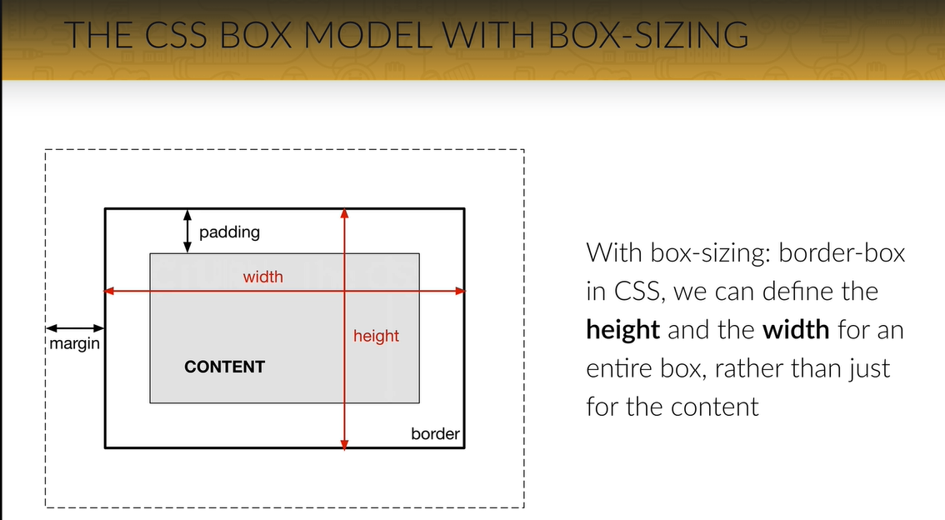
Block Element: The block use the full width of browser and force line break ,eg: headings and paragraph’s
Inline Element: Does not enforce link break or take full width and you can set their height and width eg:link and images
By default browser has some marigns and padding to remove that
/* * it repressnt all the elemnt */
*{
margin: 0px;
padding:0px;
box-sizing:border-box; /* settin all the element to border box*/
}

LIST of CSS STYLES

- Color: It tells color of text and they are way to defined it name,hex value,rgb eg:color:red/#1d7a7/rgb(29,167,23). rgba(29,167,23,0.75), fourth is for transparency of color
- Background-color: It tells background of color syntax same as above just add “background-” before color.
- Font-size: It tells text size, eg:font-size:14px/pt/in etc
- Font-family: It tells text it font language eg: font-family: Arial, Helvetica, sans-serif; here we can see there are three font-language , if first is not available in application goes for second , if all not present application takes its default font language, first is priority.
- Text-align: Alignment of text ,to right or left or justify or inhert etc eg:text-align:justify;
- left – The default value. Content aligns along the left side.
- right – Content aligns along the right side.
- center – Content centers between the left and right edges. White space on the left and right sides of each line should be equal.
- justify – Content spaces out such that as many blocks fit onto one line as possible and the first word on that line is along the left edge and the last word is along the right edge.
- inherit – The value will be whatever the parent element’s is.
- Margin: is show in fig above it push expand from border eg:margin:20px, it push all side 20px, can be use specifi by giving following
- Margin-top:20px pushes top
- Margin-right:20px pushes right
- Margin-bottom:20px pushes bottom
- Margin-left:20px pushes left
- Or can given in single Margin: top right bottom left

- padding: is show in fig above it push expand upto border eg:padding:20px, it push all side 20px, can be use specifi by giving following
- padding-top:20px pushes top
- padding-right:20px pushes right
- padding-bottom:20px pushes bottom
- padding-left:20px pushes left
- Or can given in single padding: top right bottom left

- Width and Height : tells the height and width of element eg: width:20px/%/in etc, eg: height:20px/%/in etc
- Float : Move/position the element(tag) eg:float:left
- Box-sizing: tell to increase width or not eg:box-sizing:border-box
- if we give width 200 px use content-box , it increase width on adding padding, border etc
- if we give width 200 px use border-box , it does increase width on adding padding, border etc, it keeps width as 200px
- text-rendering: The text-rendering property in CSS allows you to choose quality of text over speed (or vice versa) allowing you to fine tune optimization by suggesting to the browser as to how it should render text on the screen. Eg: text-rendering: optimizeLegibility;
- Border-radius: The border-radius CSS property rounds the corners of an element's outer border edge. You can set a single radius to make circular corners, or two radii to make elliptical corners
Eg:
/* The syntax of the first radius allows one to four values */
/* Radius is set for all 4 sides */
border-radius: 10px;

/* top-left-and-bottom-right | top-right-and-bottom-left */
border-radius: 10px 5%;

/* top-left | top-right-and-bottom-left | bottom-right */
border-radius: 2px 4px 2px;

/* top-left | top-right | bottom-right | bottom-left */
border-radius: 1px 0 3px 4px;

second one changes side and first for corner

/* The syntax of the second radius allows one to four values */
/* (first radius values) / radius */
border-radius: 10px / 20px;

/* (first radius values) / top-left-and-bottom-right | top-right-and-bottom-left */
border-radius: 10px 5% / 20px 30px;

/* (first radius values) / top-left | top-right-and-bottom-left | bottom-right */
border-radius: 10px 5px 2em / 20px 25px 30%;

/* (first radius values) / top-left | top-right | bottom-right | bottom-left */
border-radius: 10px 5% / 20px 25em 30px 35em;

/* Global values */
border-radius: inherit;
border-radius: initial;
border-radius: unset;

Web design Tips:
Beautiful Typography
1. Use a font-size between 15 and 25 pixels for body text
2. Use (really) big font sizes for headlines
3. Use a line spacing between 120 and 150% of the font size
4. 45 to 90 characters per line
5. Use good fonts
6. Chose a font which reflects the look and feel you want for your website
7. Use only one font

Using Colors Like a Pro
1. Use only one base color
2. Use a tool if you want to use more colors
3. Use color to draw attention
4. Never use black in your design
5. Choose colors wisely

Working with Images
1. Put text directly on the image
2. Overlay the image
3. Put your text in a box
4. Blur the image
5. The floor fade

Working with icons
1. Use icons to list features/steps
2. Use icons for actions and links
3. Icons should be recognizable
4. Label your icons
5. Icons should not take a center stage
6. Use icon fonts whenever possible

Spacing and layout
1. Put whitespace between your elements
2. Put whitespace between your groups of elements
3. Put whitespace between you website's sections
4. Define where you want your audience to look first
5. Establish a flow that corresponds to your content's message
6. Use whitespace to build that flow
Before stating project please have this
1. Define your project
- Start off by defining the goal of your project. This can be showing your portfolio to the world, selling an e-book, building a blog, etc.
- Also define your audience. Ask yourself: which is the typical user that will visit my website?
- This is important, because you should always design with your goal and audience in mind.

2. Plan out everything
- Once your project is defined, plan your content carefully. This includes text, images, videos, icons, etc.
- Remember what I told you about visual hierarchy. It plays an important role when you start thinking about what you want on your website and what you don't. Defining the content before actually starting the design is called the content-first approach. It means that you should design for the content, instead of designing a webpage and then filling it with some stuff.
- Define the navigation.
- Define the site structure. You can draw a sitemap in this step if we're talking about a bigger project.

3. Sketch your ideas before you design
- Now it's time to get inspired and think about your design.
- Then, get the ideas out of your head. And with that I mean that you should sketch your ideas before you start designing. It will help you explore ideas and create a concept of what you want to build. Using pencil and paper is a great way of quickly retaining your valuable ideas.
- Make as many sketches as you want, but don't spend too much time perfecting anything. Once you have an initial idea, you can concentrate on the details when designing in HTML and CSS.
- I advise you to never, ever start designing without having an idea of what you want to build. Getting inspiration is very important in this phase, and I already told you how to do that!

4. Design and develop your website
- After sketching, start to design your website using all the guidelines and tips you've learned in the web design section.
- You'll do that using HTML and CSS, which is called designing in the browser. Designing in the browser is basically designing and developing at the same time.
- There are more and more designers leaving traditional design programs such as Photoshop and start designing in the browser. The biggest reason for this is that you can't design responsive websites in photoshop. It also saves you tons of time.
- In this phase, you'll use your sketches, content and planning decisions you've made in steps 1, 2 and 3.

5. It's not done yet: optimization
- Before you can actually launch your beautiful masterpiece for the world to see it, we have to optimize its performance in terms of site speed.
- You also need to do some basic search engine optimization (SEO) for search engines such as google.

6. Launch the masterpiece
- Your optimized website is now finally ready to launch.
- All you need for launching is a webserver that will host your website and deliver it to the world.

7. Site maintenance
- The launch of your website is not the end of the story.
- Now it's time to monitor your users' behavior and make some changes to your website if necessary.
- You should also update your content regularly in order to show your users that your website is alive! For instance, a blog can be a great way of doing that.
Common Q& A

1. My code is broken and I can’t move forward in the course. What should I do?
Don’t panic, this is completely normal :)
Start by spending some time trying to solve the problem on your own. This is very important for your learning process! To find errors, you can compare your code with the downloadable code for each section.
If you really can’t solve the problem on your own, please post your code to a new codepen (http://codepen.io/pen/), hit save, copy your link and start a new post in the Q&A.
Please explain your problem in a very specific way: that will guarantee you get a good answer! You can even post a screenshot of the problem (not the code!).

2. Brackets: Live preview not working. What to do?
It's very difficult for me to find out what's wrong with Brackets on your computer. Sometimes it's enough to just restart Brackets or the Chrome window.
If that doesn't help, please try the official Brackets troubleshoot guide on github:
https://github.com/adobe/brackets/wiki/Troubleshooting#livedev
You can also just ignore Live Preview and open the index.html file directly.

3. Brackets: Quick edit not working. What to do?
I have actually stopped using the quick edit functionality long ago, because it never really works as expected, so don't worry about it. You don't need to use quick edit at all. Just add the code to your CSS stylesheet wherever you see fit.

4. Brackets: What are those weird JSLint warnings?
These errors that Brackets shows you are because it expects pure JavaScript code, and not jQuery code, as we are using here. In other words, Brackets thinks we have errors in our JavaScript code, because it doesn't seem to understand that we're using the jQuery framework.

5. How does the vertical centering in the header work?
Please see the following answer about this question here:
https://www.udemy.com/design-and-develop-a-killer-website-with-html5-and-css3/learn/v4/questions/851800

6. My icons are not working. What can I do?
Sometimes using the icons on the local computer doesn't work very reliably. Please use the following icons instead:
<link rel="stylesheet" type="text/css" href="https://cdnjs.cloudflare.com/ajax/libs/ionicons/2.0.1/css/ionicons.css">

7. The background image looks different in the course, it doesn’t move. Why?
I show you how to do that effect later in the course, it appeared in one video by mistake because I produced one after all the other videos.
But here's how you get that effect with the background image:
background-attachment: fixed;

8. My background images looks different on iOS devices than in the course. Why?
The reason why it doesn't work is that the property:
background-attachment: fixed;
doesn't work on iOS devices. What we can do in this situation is to target iOS devices using media queries, and apply the following rule:
background-attachment: scroll;
Please take a look at this resource: https://css-tricks.com/snippets/css/media-queries-for-standard-devices/
Alternatively, you could just ignore background-attachment: fixed; altogether for smaller screen widths. That should be easier.

9. Autoprefixer is not working. What should I do?
You can try to highlight individual sections and prefix only those sections one by one, sometimes that works.
Also, it only works if you have no bugs in your CSS code at all. You can check if you have some here:
https://jigsaw.w3.org/css-validator/

10. My website is not loading correctly on a server. What’s wrong?
This problem is most likely related with lowercase and uppercase filenames. On Windows or macOS it doesn't matter if you use lowercase and uppercase in filenames. However, on the server, which is typically Linux, it does matter.
For example, if your file is called style.css and you include it in your HTML as Style.css, it won’t work on the server. So please make sure that you include all your files with the exact correct filename.

11. The responsive navigation disappears after resizing the window. Why is that?
This is actually a small bug in my code. There is a post in the Q&A that shows you how to solve that issue:
https://www.udemy.com/design-and-develop-a-killer-website-with-html5-and-css3/learn/v4/questions/821648

12. There are some other problems going on with the navigation. How can I fix these?
I already did that for you! I coded up a new version of the responsive navigation, it fixes all the issues there with the existing one.
Please replace all the navigation-related CSS code in your 767px media query by the one in this fiddle:
https://jsfiddle.net/d83ykzku/1/
Please also replace the jQuery code for the navigation with the one you can find in the link above. You can of course change the colors and style :)

13. My jQuery code is not working at all. What can I do?
Has the jQuery worked before? Are you sure you included the script.js file correctly, as well as the jQuery library? Are you using the correct class names in both HTML and jQuery code?
If your answer is YES, then post a question like I explained before.

14. The map is not working. What can I do?
Please take a look at this post in the Q&A where I solve one of the possible problems with this:
https://www.udemy.com/design-and-develop-a-killer-website-with-html5-and-css3/learn/v4/questions/1589266
https://www.udemy.com/design-and-develop-a-killer-website-with-html5-and-css3/learn/v4/questions/1967866

15. Where is the code for the bonus lectures?
Map lecture: https://jsfiddle.net/uo3uxo1f/
PHP contact form lecture: https://jsfiddle.net/mf0ydjfq/

16. When do you use px and when do you use %? I’m confused by this.
Okay, that is a very good question. So, we use px and % in different situations. We use percentages more for "layout" elements, which means elements that define the layout and that we want to change according to the screen width. Also, percentages are most useful for defining horizontal distances between elements, such as widths or margin-left or margin-right , not vertical distances, because responsive web design works with screen widths (horizontal). In other words, everything that we want to change based on the screen width when the screen becomes smaller, should be defined in %.
Also, font-sizes are always defined in %, except for the base font-size defined for the body element, so that we can easily change font-sizes for smaller screen sizes. More about that later in Section 6.
We use px to define some margins and paddings, and sometimes to define smaller distances and distances that doesn't need to change when the screen changes. For the paddings, please note that we can only use px here thanks to box-sizing: border-box; , which ensures that the box width (defined in %) always stays the same no matter how much padding we add inside of it.

17. What’s the difference between relative and absolute positioning?
Relative positioning simply positions the elements relative to the other elements on the webpage. Elements just appear on the website in the order they are defined in the HTML document. You can use margins to relatively position elements, i.e. to create space between elements.
In absolute positioning, we can use the top , bottom , left and right properties to perfectly position an element inside its relatively positioned parent, wherever we want. This gives us a lot of control, which is extremely useful, and you will see examples of this throughout the course. We need to explicitly say that the parent has position: relative, otherwise the browser would not know where to position the absolute element.

18. What’s the main difference between classes and IDs?
The main difference is that you can use classes as many times as you want on each website, but IDs only once.
This can be a problem. Imagine that you use an ID for something you think you will only use once, but later you decide you want to reuse that style. Then you'd have to go back and change from ID to class, and you’d also have to update your CSS. That's why you should only use classes and no IDs. I agree that this may not be the case with this exact project, but it will help you in the future.
The important issue here is code maintenance. It's easier to maintain code which has just classes and not a mixture of classes and IDs. That's why I have chosen to never use IDs and recommend students to do the same.
19. Why did you use the figure and ul elements for the meals section instead of just using plain img elements? (This logic applies to all questions of this type)
Please understand that in this course I had to mix a real website with teaching things to students. That's why in some circumstances, like having the figures just with an image and no caption, I do things just to show you new elements or stuff like that. That's why I used the figure element. This gives you a foundation so that you can now go ahead and add a <figcaption> to it.
As of the unordered list, this is just to make it more semantic. These images are, in fact, like a list of meals with an image, right? And if we feel like it's a list, then we should express that with HTML, even if it doesn't look any different in the final website. That's called semantic HTML, and it’s important to use it.

20. What’s the difference between the body selector and the universal selector (*)?
The universal selector simply selects each and every element on the webpage and applies the styles to all of them, unless we apply a different style somewhere else.
The body and html are different. We apply styles to the body/html elements that will be inherited by other elements. These are most commonly styles related to text, like the font-family, font-size or font-weight properties, because these properties get inherited by other elements. This means that once we define them on a parent element, all of the child elements will also get these properties automatically. And that's why we define these right on the html and body elements, because they are the parent elements of all the other elements.

21. Why does the order in which we place the scripts matter?
Our own script.js file should always be the last one. That's because of the dependencies we have in our code. For example, with jQuery, we use it in our script.js file., so it's a dependency. And we need to load that dependency before we can use it, of course. And that's why the jQuery should be loaded first. And the same of course applied to other external scripts.

22. How and why does the clearfix hack work?
The .clearfix class has the pseudo-element :after because we want to properties, especially clear: both (which does the real work of clearing the floats) to happen at the end of the element (after) on which we use the clearfix class. As for the other properties, there is no real explanation, this is just a "hack", which means that it solves the problem in a strange way. This (or in a slightly different version) is how everybody uses the clearfix.

23. Can I build an app/shopping cart/store with this course?
So this course only covers HTML and CSS, which are front-end technologies, or client-based technologies, meaning that these run in the user's browser. You use them to build the user interface that the user sees and interacts with.
Now, a shopping cart is somewhat different, because it involves some functionality, some logic, that needs to be programmed. We can't do that with HTML and CSS. This is called back-end development, and it usually involves a server and database, and you need some more advanced coding skills for it.
You can learn some more on this blog post I wrote some time ago:
http://codingheroes.io/blog/
24. What’s the difference between Bootstrap and the grid system used in the course?
The difference between Bootstrap and this small Grid System is that Bootstrap is an entire framework including thousands of lines of HTML, CSS and JavaScript, which you can use for quickly building a website using pre-defined building blocks. It also includes a sophisticated grid system. Now, the Grid System we use in this course is just a small CSS file which defines the rows and columns of our small fluid grid. If you look at the code, you'll see it's so simple that you could even hand-code it yourself :)
I thinks it's important to learn Bootstrap as well, because it's most likely the most popular framework in the world, but it's equally important to first fully understand the fundamentals of HTML, CSS and responsive web design without any framework.

25. What’s your opinion about Wordpress, Wix, etc?
In my opinion, before you start creating websites using one of these tools, you should know how the underlying technologies of web development work, and that's HTML, CSS and also JavaScript (not so much covered in this course, but in a future course).
First, knowing the fundamental building blocks of the web allows you to create 100% custom websites without any themes or constraints. You are not bound to a template or theme that someone else designed. Creativity is the only limit when you really know what you're doing, and that is very empowering.
Second, I think it's far more professional to actually know how stuff works under the surface, then just make a website for a client using some Wordpress theme or wix template.
And third, HTML, CSS and JavaScript are used to build web applications, so if you want to do that, you obviously will have to know them really well.

